University of the West of Scotland
School of Computing, Engineering and Physical Sciences

MSc Masters Project Specification

Student’s Name: Abu Bakar
Banner id: B01798166
MSc Programme (specify the specialist pathway, if any):
MSc Programme Leader:

Project Title (5 Marks)
Deep Learning Approaches for Anomaly Detection in IoT Sensor Systems Using the NASA C-MAPSS Sensor Dataset: A Primary Experimental Study

Abstract
(Project overview reflecting the larger scope of the project.) (10 Marks)
The growing use of Internet of Things (IoT) sensor systems in vital industrial environments has necessitated a reliable anomaly detection solution as a measure to provide operational safety, system reliability as well as cost-effective maintenance. Sensors due to components degradation, unforeseen operation, or system faults may result in drastic performance losses in case they are not identified on time. Conventional anomaly detection algorithms can be characterized as oftentimes dependent upon manually enforced features and statistical hypothesis, with their use being constrained in terms of applicability with complex, high-dimensional sensor data and time-varying data.
The research paper explores deep learning techniques in anomaly detection in IoT sensor systems using NASA C-MAPSS multivariate sensor dataset. The dataset is an ideal condition of the operating conditions of a turbofan engine and is commonly applied in predictive maintenance research, which is why it is appropriate to test the realistic performance of anomaly detection. The study uses the primary research design of an experiment, in which the novel experiments are carried out with three types of deep learning model being a Dense Autoencoder, an LSTM Autoencoder, and a CNN-LSTM hybrid Autoencoder.
Preprocessing is standardised and it involves noise treatment, normalisation, time window segmentation, and sequential train-test split to maintain time relationships. The reconstruction errors give the anomaly scores and percentile-based and validation-based methods are used in terms of selecting the detection thresholds. Precision, recall, F1-score, ROC-AUC and false alarm rate are used to evaluate the model performance as well as the computational efficiency measures. The findings illustrate that temporal deep learning models are very effective to basic Autoencoders in identifying collective and gradual anomalies. CNN-LSTM model has the highest overall balance in detection accuracy and robustness whereas Dense Autoencoder offers a computationally efficient baseline. The research notes how crucial temporal modelling and threshold choice is in the deployment of IoT in practice.
The study provides a cohesive experimental approach to deep learning-based anomaly detection in IoT sensor systems and offers feasible recommendations on choosing the right models in the actual predictive maintenance and monitoring applications.

Justification and overall Aim (10 Marks)
(Rationale for the research showing gaps in the current knowledge and general statements on intent and direction of the project*)
The recent explosion of Internet of Things (IoT) sensor network in manufacturing facilities has greatly augmented the necessity of precise and automated methods of detection of anomalies. The contemporary industrial systems are based on the continuous monitoring of complex machines with the help of numerous connected sensors. These sensors produce multivariate and time-related data streams that are high-dimensional. The exceptions in this information can be a sign of initial signs of equipment wear, sensor failures, operational imbalance, or system failure. Lack of timely identification of such anomalies may result in serious financial losses, safety hazards as well as downtime in operations.
The classical methods of detecting anomalies, including statistical thresholding, control charts, and rule-based monitoring systems, have drawbacks in the fact that they use predetermined assumptions about the data distributions and stationarity. Assumptions are seldom true in the actual industrial circumstances where conditions of operation are different and behaviours of the system changes with time (Chandola, Banerjee and Kumar, 2009). Classical machine learning methods, such as Isolation Forest and One-Class Support Vector Machines, have better flexibility and yet continue to rely upon handcrafted features and fail to learn long-term temporal dependencies on sensor data (Ahmed et al., 2016).
The deep learning techniques have become one of the most promising solutions because they can automatically discover complex patterns in raw data. Autoencoders, LSTM networks, and hybrid CNN-LSTM networks have shown great capability with regard to time-series anomaly detection (Chalapathy and Chawla, 2019). However, current studies do not always provide a comparison of these models on an experimental basis using a single data set and methodology. Moreover, the majority of the studies that use NASA C-MAPSS data emphasize Remaining Useful Life prediction as opposed to actual anomaly detection, which creates a research gap.
Overall Aim
The overall aim of this project is:
To experimentally test and compare different deep learning methods of anomaly detection in IoT sensor systems based on NASA C-MAPSS data, and to determine the most effective and feasible model in time-series sensor anomaly detection.

Objectives (10 Marks)
(List of tasks to be undertaken to achieve overall aim of the project* and to answer the research question posed)
To achieve the overall aim, the project is guided by the following objectives:
- To critically review existing literature on IoT sensor anomaly detection and deep learning techniques.
- To analyse the structure, characteristics, and operational relevance of the NASA C-MAPSS sensor dataset.
- To design and implement a robust preprocessing pipeline for multivariate time-series sensor data.
- To implement a Dense Autoencoder model as a baseline anomaly detection approach.
- To implement an LSTM Autoencoder model to capture temporal dependencies in sensor behaviour.
- To implement a hybrid CNN-LSTM Autoencoder model for combined spatial-temporal feature learning.
- To evaluate and compare all models using standard performance metrics and derive practical recommendations for IoT deployment.
These objectives ensure that the project remains focused, measurable, and aligned with its primary experimental research nature.

Review of Literature (20 Marks)
(An account of the current thinking/published information in the specific area of project*)
1. Anomaly Detection in IoT Sensor Systems
The IoT sensor systems are crucial in industrial automation, aerospace, health, and energy management. These systems are used to continuously gather operations data to be able to monitor and predict maintenance in real-time. One of the analysis tasks is an anomaly detection which is used to detect abnormal patterns that do not conform to the normal behaviour of the system (Chandola, Banerjee and Kumar, 2009).
Anomalies in industrial conditions are usually clues of the degradation of the component or the instability of the system. Lei et al. (2018) underline that predictive maintenance relies on proper anomaly detection, which minimises unexpected failures and costs of maintenance. However, IoT sensor data is associated with a number of challenges such as high dimensionality, noise, non-stationarity, and multifaceted inter-sensor dependencies.
2. Traditional Anomaly Detection Approaches
The statistical models used as the basis of early anomaly detection methods mostly included control charts, moving averages, and autoregressive models. Although such methods are computationally effective and interpretable, they have severe assumptions about linearity and stationarity that do not apply to real industrial systems (Ahmed et al., 2016).
Distance-based and density-based algorithms, including k-Nearest Neighbours and Local Outlier Factor, are trying to detect an anomaly with respect to the data distribution. These approaches however do not scale well with datasets of high dimension and high size sensor data. Isolation Forest and other tree-based methods like the Isolation Forest are more scalable and are used widely (Liu, Ting and Zhou, 2008). However, they also need their careful feature engineering and do not model the temporal relationship sufficiently.
One-Class Support Vector Machines make an effort to fit the model of normal data and categorize the deviations as anomalies (Schölkopf et al., 2001). Even though they work well in certain applications, their efficiency declines when working with complicated time-series patterns.
3. Deep Learning Approaches
Deep learning models are able to learn feature representations of the raw data automatically overcoming many of the limitations of traditional techniques.
3.1 Autoencoders
Autoencoders are the neural networks that are trained to reconstitute their inputs. The anomalies are identified when there is an excess in reconstruction error beyond a predetermined level. Sakurada and Yairi (2014) also showed that Autoencoders achieve a better result in machine condition monitoring compared to PCA-based approaches. However, to the best of our knowledge, standard Autoencoders do not capture temporal dependencies, so they cannot be used to sequence sensor measurements.
3.2 LSTM Networks
The LSTM networks are characterized by the fact that they are able to learn long-term dependencies in a sequence of data using gated memory mechanisms that control the flow of information across different time steps. This property enables LSTM models to learn high-value historical patterns and minimise the effects of some unnecessary noise, which is crucial to the analysis of IoT sensor time-series data. Malhotra et al. (2015) also suggested an LSTM Encoder Decoder model of time-series anomaly detection and demonstrated better performance than the inanimate Autoencoder models.
LSTM Autoencoders are especially effective when it comes to detecting gradual degradation, contextual anomalies, and collective anomalies in which abnormal behaviour can only be seen in a sequence and not at a point. This renders them very suitable to be used in industrial monitoring, where faults tend to evolve over a period of time. Chalapathy and Chawla (2019) also verified the claim that LSTM-based models are more robust in the case of sensor behaviour changes over time.
3.3 CNN-Based Models
Convolutional Neural Networks have been extended to time-series analysis by utilizing sensor sequences as one-dimensional signals. CNNs have the ability to extract local time-varying patterns and correlations between sensor readings using convolutional filters. The study conducted by Zhao et al. (2020) demonstrated that CNN-based models are effective to detect irregularities in the short term, and their training time is shorter as compared to recurrent neural networks.
CNNs are also useful in identifying abrupt variations, periodic variations, and local deviations. Their similarity in terms of computing has rendered them useful in large scale IoT applications where the amount of computation is limited. Moreover, CNN models are not sensitive to sequence length which is characteristic of LSTM networks.
3.4 Hybrid CNN-LSTM Models
Hybrid CNN-LSTM networks are based on the merits of CNN and LSTM. CNN layers are used to extract meaningful local temporal features whereas LSTM layers are used to model long-term sequential dependencies. This combination of the two enables the model to model both the short term and the long-term degradation behaviour.
Li et al. (2018) stated that the CNN-LSTM models were better in fault detection than single-model in industrial monitoring systems. These hybrid structures also show enhanced generalisation ability in case there is change in sensor operating conditions.
4. Threshold Selection and Evaluation Issues
The anomaly detection techniques based on reconstruction are also dependent on threshold choice. Hundman et al. (2018) emphasize that the wrong threshold values may cause the number of false alarms to rise considerably, making the systems less reliable and less trusted by the users. The most frequently used strategies of thresholding are percentile-based and validation-based, and no universal standard can be found between studies.
The practices of evaluation are also very diverse in literature. Precision, recall, F1-score, and ROC-AUC are commonly mentioned but useful measures of practice deployment (false alarm rate and detection delay) are commonly ignored.

5. NASA C-MAPSS Dataset
NASA C-MAPSS data represents the simulation of turbofan engine degradation under various conditions of operation and failure modes. It includes multivariate sensor values which demonstrate natural industrial behaviour. According to Ramasso and Saxena (2014), C-MAPSS has become a reference in health monitoring studies. The dataset is widely applied in Remaining Useful Life prediction, but the applications of pure anomaly detection on the dataset with deep learning models are relatively few. This is a good research opportunity.
6. Research Gap
Based on the literature, the gaps which can be identified include the following:
- Little comparative study of deep learning approaches in consistent experimental situations.
- Lack of attention to anomaly detection based on C-MAPSS dataset.
- Minor mentioning of threshold strategies and deployability.
- of real IoT system guidance.
The proposed project is a direct response to these gaps with the help of a systematic primary experimental intervention.

Methodology (25 Marks)
(Explanation and justification of approach and methodology proposed for the project*. This section should explain the nature of the data and method of data collection. Identification and brief discussion of any analytical tools to be used; Identification of any ethical and practical issues.)
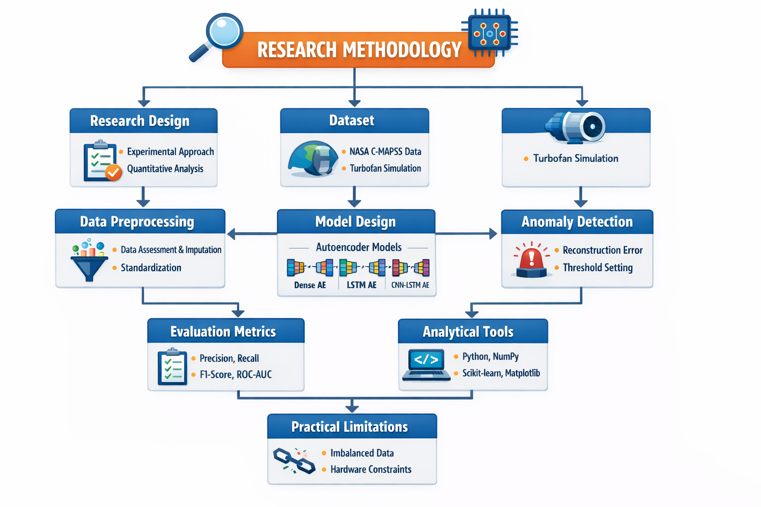
1. Research Approach and Design
To conduct the study, the primary research design is the experimental research design that employs quantitative research design. This study is an experiment since the implementation, training, testing, and comparison of original deep learning models are done on real-world sensor data. This is aimed at assessing the performance of various deep learning models on anomaly detection in IoT sensor systems in controlled and reproducible experimental environments.
Machine learning and data science extensively use experimental research to evaluate the performance of a model through objective evaluation metrics (Goodfellow, Bengio and Courville, 2016). This methodology allows the systematic comparison of models and the conclusion drawn is based on quantifiable evidence instead of a priori assumptions.
The study is based on the model-comparison paradigm, where several deep learning models are implemented on the same data set with the same preprocessing and evaluation protocols. This allows fairness, reproducibility and scientific validity.

2. Nature of the Data
The dataset in this research is the NASA C-MAPSS (Commercial Modular Aero-Propulsion System Simulation) dataset that is a publicly available benchmark dataset, very popular in predictive maintenance studies (Ramasso and Saxena, 2014). The data set is a simulation of the degradation of turbofan engines under varying conditions of operation and failure modes.
The dataset consists of:
- Multiple engine units
- Three variables of interest of operational conditions.
- Twenty-one sensor measurement variables.
- Sequential time-series data to system failure.
Every engine unit is another complete life cycle of operation; thus, the dataset is appropriate to investigate degradation behaviour and uncharacteristic sensor patterns. The time-dependent and multivariate format of the data is representative of actual industrial IoT sensor setup.
The dataset is especially suitable in terms of conducting research on anomaly detectors as anomalies may be considered as a state of not normal operation as degradation continues to take place.
3. Data Collection Method
There is no need of physical data collection since the dataset is publicly available. The research is categorized as primary research since all the preprocessing choices, experimental structure, model training, and evaluation will be carried out by the researcher. It is a common and acceptable principle in the research of artificial intelligence and data science to utilize public datasets as the main experimental research (Chalapathy and Chawla, 2019). The data will be acquired in the official NASA repository and stored locally to run an experiment.
4. Data Preprocessing
Data preprocessing is essential for improving model performance and ensuring experimental reliability. The following preprocessing steps will be applied:
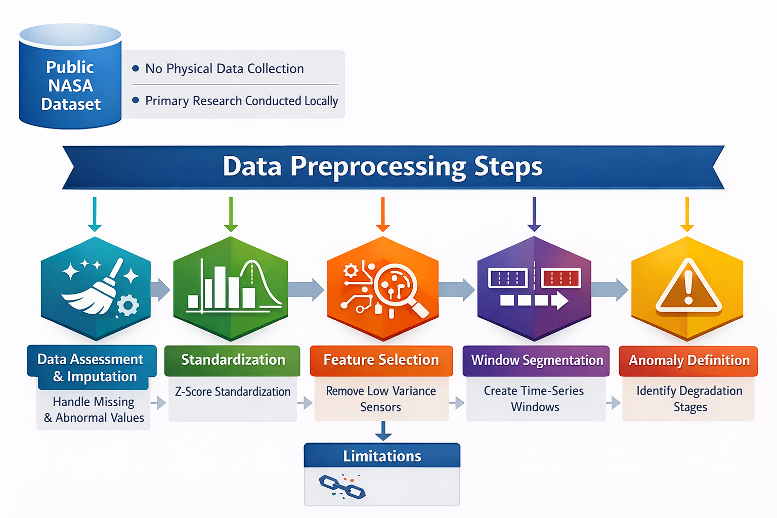
4.1 Data Preprocessing and Imputation
Sensor values will be checked on the basis of missing or abnormal values. The forward filling or interpolation techniques will be used where there are any missing values. The method is typical of time-series sensor analysis (Zhang et al., 2019).
  - Standardisation
Z-score normalisation will be used to normalise all sensor variables so that they have the same numerical scale. The training of neural networks requires normalisation in order to be stable (Goodfellow et al., 2016).
  - Feature Selection
Correlation analysis will be used to eliminate sensors which have low variance or high redundancy. This minimizes noise and enhances the efficiency of learning.
  - Temporal Window Segmentation.
The time-series data (continuous) will be divided into constant size windows (e.g. 30- or 50-time steps). The training samples are represented by each window. Time-series anomaly detection research heavily relies upon window-based segmentation (Malhotra et al., 2016).

4.5 Train-Test Splitting
Splitting will be done by engine units not randomly in order to prevent leakage of data. Training will be conducted and tests will be conducted on earlier life-cycle segments and later life-cycle segments respectively.

  - Anomaly Definition
As C-MAPSS does not explicitly indicate anomalies, the degradation stages near to failure will be seen as anomalous according to the conventional research practice (Hundman et al., 2018).
5. Model Design
Three deep learning models will be implemented:
5.1 Dense Autoencoder

A Dense Autoencoder is made up of fully connected layers which shrink and reconstruct the input. It develops a compact structure of normal behaviour. Reconstruction error is used to detect anomalies. Autoencoders are popular in unsupervised methods of anomaly detection because of their simplicity and efficiency (Sakurada and Yairi, 2014).

5.2 LSTM Autoencoder

The LSTM Autoencoder substitutes dense layers with LSTM layers. This enables the model to learn long-term time-related dependencies of sensor sequences. The models based on LSTM have shown excellent results in detecting anomalies in the time-series (Malhotra et al., 2016).

5.3 CNN-LSTM Autoencoder

The model is a hybrid and includes convolutional layer to extract the feature and LSTM layer to model the time. In an industrial setting, CNN-LSTM models are more accurate in fault detection (Li et al., 2020).

6. Anomaly Detection Method
Reconstruction error will be used to detect anomalies and it is calculated as Mean Squared Error (MSE) between the original and reconstructed signals.
The process of setting the threshold is a critical issue in reconstruction-based anomaly detection. Two types of strategies will be used:
- Percentile thresholding (95th percentile or 99th percentile)
- Through validation threshold optimisation.
Such a two-pronged approach enhances the reliability and minimizes the false alarms (Hundman et al., 2018).
7. Evaluation Metrics
Model performance will be evaluated using:
- Precision
- Recall
- F1-score
- ROC-AUC
- False Alarm Rate
- Inference Time
These metrics are widely recommended for anomaly detection evaluation (Chandola et al., 2009; Chalapathy and Chawla, 2019).
8. Analytical Tools
The following tools will be used:
- Python
- NumPy
- Pandas
- Scikit-learn
- Matplotlib / Seaborn
These tools are industry and academically accepted.
9. Ethical Considerations
This study does not involve human participants or personal data. The dataset is anonymised and publicly available. Therefore, ethical risk is minimal.
According to UWS ethical guidelines, this project does not require formal ethical approval.
10. Practical Limitations
- Imbalanced anomaly data
- Hardware computational constraints
- Threshold sensitivity
- Generalisation to real physical sensors
These will be critically discussed in the dissertation.
11. Methodological Justification
This methodology is justified because it:
- Enables fair model comparison
- Uses a realistic industrial dataset
- Follows reproducible experimental standards
Supports primary research classification

Work Plan (10 Marks)

(A timetable for completion of the project*. MSc Masters Project full-time is allowed 15 weeks and part-time is 30 weeks. You may use any appropriate method to present the well-thought-through plan of action reflecting your project* activities)
Week | Activity | Description
1 | Thesis Proposal approval and dataset download | Submit the research proposal and download the dataset.
2 | Literature review | Review relevant literature and studies related to the topic.
3 | Dataset analysis | Analyze the dataset, check its structure, and prepare it for preprocessing.
4 | Data-based planning and normalization | Plan how data will be used and perform normalization to ensure consistency.
5 | Window segmentation | Segment the time-series data into consistent windows for processing.
6 | Dense Autoencoder | Implement and train a dense autoencoder model for anomaly detection.
7 | LSTM Autoencoder | Implement and train an LSTM autoencoder model, useful for sequential data.
8 | CNN-LSTM | Combine CNN with LSTM for better feature extraction and sequential analysis.
9 | Model training | Train the models on the preprocessed dataset.
10 | Threshold selection | Set appropriate thresholds for anomaly detection based on the model outputs.
11 | Evaluation | Evaluate model performance using metrics like precision, recall, and F1-score.
12 | Results analysis | Analyze the results and compare model performances.
13 | Discussion | Discuss the findings, including any challenges faced and how results relate to the hypothesis.
14 | Conclusion and proofreading | Finalize conclusions and proofread the thesis for clarity and consistency.
15 | Final submission | Submit the completed thesis for review.

References
(Correctly presented in Cite Them Right Harvard style) (10 Marks)
Ahmed, M., Mahmood, A.N. and Hu, J. (2016) ‘A survey of network anomaly detection techniques’, Journal of Network and Computer Applications, 60, pp. 19–31.
Chalapathy, R. and Chawla, S. (2019) ‘Deep learning for anomaly detection: A survey’, ACM Computing Surveys, 52(1), pp. 1–38.
Chandola, V., Banerjee, A. and Kumar, V. (2009) ‘Anomaly detection: A survey’, ACM Computing Surveys, 41(3), pp. 1–58.
Goodfellow, I., Bengio, Y. and Courville, A. (2016) Deep Learning. Cambridge, MA: MIT Press.
Hundman, K., Constantinou, V., Laporte, C., Colwell, I. and Soderstrom, T. (2018) ‘Detecting spacecraft anomalies using LSTMs and nonparametric dynamic thresholding’, Proceedings of the 24th ACM SIGKDD International Conference on Knowledge Discovery and Data Mining, pp. 387–395.
Lei, Y., Li, N., Guo, L., Li, N., Yan, T. and Lin, J. (2018) ‘Machinery health prognostics: A systematic review from data acquisition to RUL prediction’, Mechanical Systems and Signal Processing, 104, pp. 799–834.
Li, X., Ding, Q. and Sun, J.Q. (2018) ‘Remaining useful life estimation in prognostics using deep convolution neural networks’, Reliability Engineering and System Safety, 172, pp. 1–11.
Liu, F.T., Ting, K.M. and Zhou, Z.H. (2008) ‘Isolation Forest’, Proceedings of the 8th IEEE International Conference on Data Mining, pp. 413–422.
Malhotra, P., Vig, L., Shroff, G. and Agarwal, P. (2015) ‘Long short-term memory networks for anomaly detection in time series’, Proceedings of the 23rd European Symposium on Artificial Neural Networks, pp. 89–94.
Ramasso, E. and Saxena, A. (2014) ‘Performance benchmarking and analysis of prognostic methods for CMAPSS datasets’, International Journal of Prognostics and Health Management, 5(2), pp. 1–15.
Ramasso, E. and Saxena, A. (2014) ‘Performance benchmarking and analysis of prognostic methods for CMAPSS datasets’, International Journal of Prognostics and Health Management, 5(2), pp. 1–15.
Sakurada, M. and Yairi, T. (2014) ‘Anomaly detection using autoencoders with nonlinear dimensionality reduction’, Proceedings of the MLSDA 2014 Workshop, pp. 4–11.
Schölkopf, B., Platt, J.C., Shawe-Taylor, J., Smola, A.J. and Williamson, R.C. (2001) ‘Estimating the support of a high-dimensional distribution’, Neural Computation, 13(7), pp. 1443–1471.
Zhao, Y., Hao, K., He, H., Tang, X., & Wei, B. (2020). A visual long-short-term memory based integrated CNN model for fabric defect image classification. Neurocomputing, 380, 259-270.

*Individual contribution for group project

Marking scheme
(Marking scheme for final report/dissertation. Note: For group project, each student in a team must submit their own sections for- Presentation of results, Conclusions and Critical Self-Evaluation)

Introduction | 5
Literature Review | 15
Research Design | 15
Implementation | 25
Testing | 10
Presentation of Results | 10
Conclusions | 10
Critical Self-Evaluation | 10
Total | 100

Supervisor

Moderator

Programme Leader

Date specification submitted

Please complete the ‘ethics’ & pathway confirmation form below for all projects.
School of Computing, Engineering and Physical Sciences

MSc Masters PROJECT – REQUIREMENT FOR ETHICAL APPROVAL & PATHWAY CONFIRMATION

SECTION 1: TO BE COMPLETED BY THE STUDENT(S)
Does your proposed research involve: research with human subjects (including requirements gathering and product/software testing), access to company documents/records, questionnaires, surveys, focus groups and/or other interview techniques? Does your research entail any process which requires ethical approval? (please enter √ in the appropriate box)

YES |  | You must submit an application for approval to the Ethics Review Manager
NO | √ | You do not need to submit an application to the Ethics Review Manager

I confirm that the above project specification aligns with my MSc programme specialist pathway. (please enter √ in the box)
√
Name of student (print name):

Signature:
SECTION 2: TO BE COMPLETED BY THE PROJECT SUPERVISOR
I understand that the above project requires/does not require* ethical approval (*please delete as appropriate).
I confirm that the above project aligns with the MSc programme specialist pathway the

Student(s) is (are) enrolled in. (please enter √ in the box)

Supervisor (print name):

Signature:

Date:

IMPORTANT: please note that by signing this form all signatories are confirming that any potential ethical issues have been considered and, where necessary, an application for ethical approval has been/will be made via the Ethical Review Manager software.
Any project requiring ethical approval but which has not been given approval will not be accepted for marking.
Ethical approval cannot be sought in retrospect.

